OOPS Project
University Management System
Students’ Details
1.Name – VIVEK UPADHYAY ROLL NO – 2021BCS-071
2.Name – HARSH JHA ROLL NO – 2021BCS-078
2.Name – ANUP SINGH ROLL NO – 2021BCS-015

UML CLASS DIAGRAM:-
UNIVERSITY MANAGEMENT SYSTEM
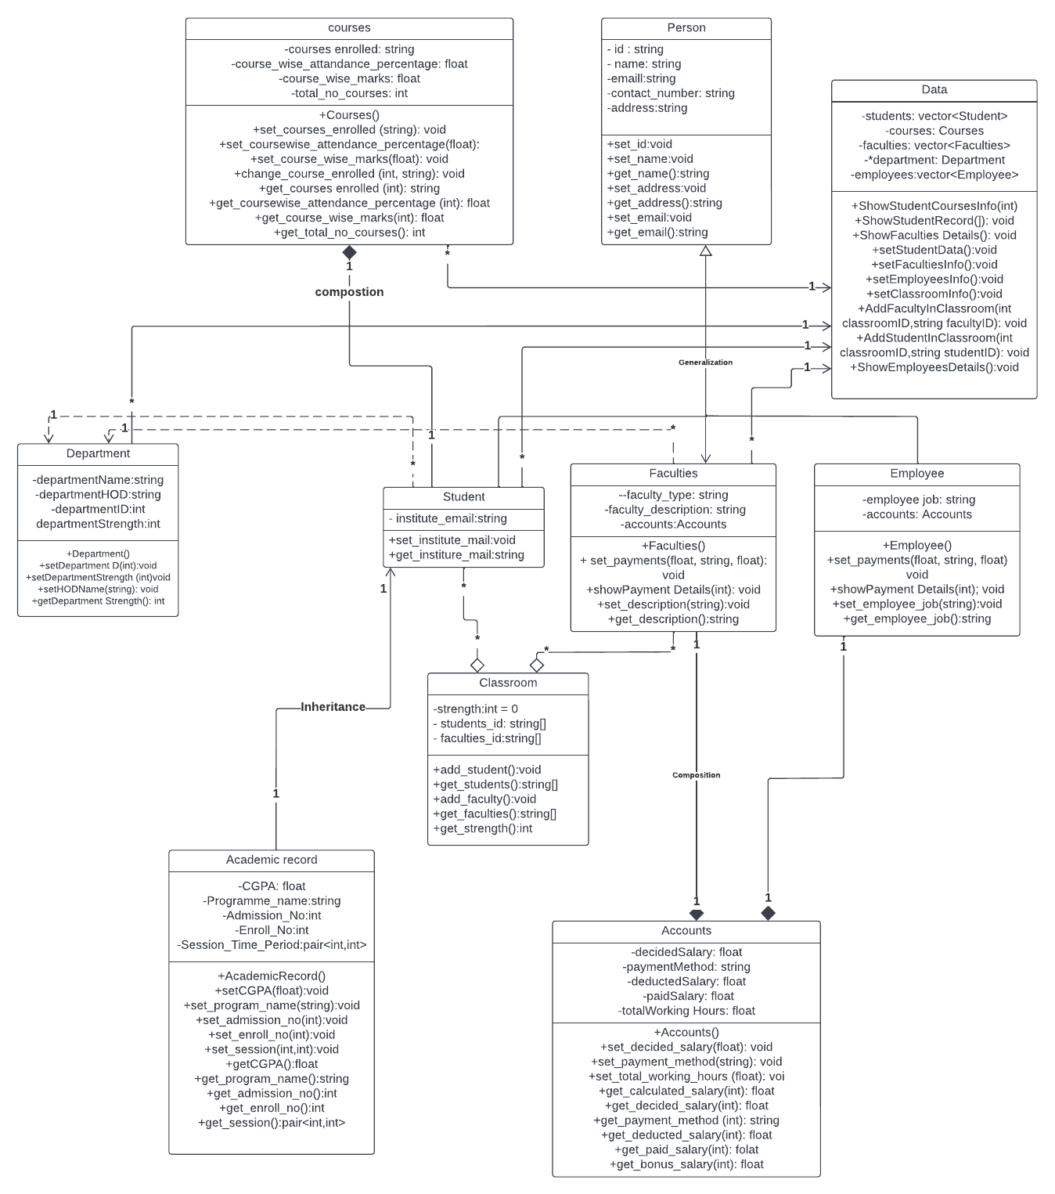

Explanation:-
We are building a University Management System, in which we have functionalities for:-
1.Add a new student in the university
2.Show the details of all students
3.Show the Academic Record of all students
4.Show the Courses opted by a particular student
5.Add a new faculty in the university
6.Show the details of all faculties in university
7.Show the details of accounts of all faculties
8.Add a new employee in the university
9.Show the details of all employees in university
10.Show the details of accounts of a particular employee

For this we have a :-
1. Person class:-
- Person class is in Person.h header file.
- This is a parent class to Student, Faculties and Employees class as every person has the common characteristics and actions of a Person instance.
- Data Members are:-
  - - id : string
  - - name: string
  - -emaill:string
  - -contact_number: string
  - -address:string
All these data members are in private scope.
- Member functions are the usual setters and getters for these data members in public scope.
- There is a Generalization from Student,Faculties and Employees to Person class.
2.Department:-
- Department class is in Department.h header file.
- Department class has a dependency to Student and Faculties class, there can’t exist a Department with 0 student or 0 Faculty in it.
- Department hence is a abstract class in this sense.
- Data Members are:-
  - string departmentName;
  - string departmentHOD;
  - string departmentID; //ID of the department
  - int departmentStrength;
All data members are in private scope.
3. Academic Record:-
- AcademicRecord is being inherited by Student class.
- Every student has a unique Academic Record, no Academic Record can be same of two different students
- Data Members are:-
  - string programme_name; //Like B.TECH CSE
  - int admission_no;
  - int enroll_no;
  - pair<int,int> session_time_period; //duration of program like (2020-2024)
  - float CGPA;
  - int total_credits;
4. Courses :-
- Courses contain the information regarding the courses picked by a unique student in the university
5. Student:-
- Student class is in Student.h header file.
- The parent class of Student class are Academic Record,Person and Department.
- Student class has a composition to Courses class, as every student has some select courses opted by him.
- The Addition Data Member:-
  - Institute_Mail: string
  - A :Course class
6. Accounts
- Accounts is in Accounts.h header file.
- Accounts contain all infomation regarding salary,payment method for a employee/faculty of the University.
- Data Members:-
  - float decidedSalary;
  - string paymentMethod;
  - float deductedSalary;
  - float bonusSalary;
  - float paidSalary;//to be calculated from other data members
  - float totalWorkingHours;
7. Faculties
- Faculties class is for storing all the characteristics and functionalities regarding various function managing faculties in a university.
- Faculties has a composition to Accounts, as every has unique account details associated to them.
- Data Members:-
  - string faculty_type;
  - string faculty_description;
  - Accounts accounts;
- All data members are in private scope.
8. Employee
- Employee class is for storing all the characteristics and functionalities regarding various function managing employees in a university.
- Employee has a composition to Accounts, as every has unique account details associated to them.
- Data Members:-
  - string employee_job;
  - Accounts accounts;
- All data members are in private scope.
9. Classroom
- This class contains information of a unique class in the university
- Data Members:-
  - int strength; //total num of students
  - vector<string> students_id; //list of ID of students in the class
  - vector<string> faculties_id;//list of ID of faculties in the class
  - int classroom_id; //used as unique identifier for a classroom
These data members are in private scope.

10. Display
- This is the central class for our management system, which contains most of the functionality for University Management System.
- Data Members:-
  - vector<Student> students;
  - Courses courses; //this data members is extra
  - vector<Faculties> faculties;
  - vector<Employee> employees;
  - vector<Classroom> classrooms;
Above data members are in private scope.
  - int total_students = 0;
  - int total_faculties = 0;
These data members are in public scope.

Output:-
